John Carroll
jcc0044/902521946

Computer Architecture
Homework 9
Theme: Pipelining
All questions are of equal weight. Show your work.

- Consider the timing diagram of Figure 14.10. Assume that there is only a two-stage pipeline (fetch, decode and execute). Redraw the diagram to show how many time units are now needed for four instructions.
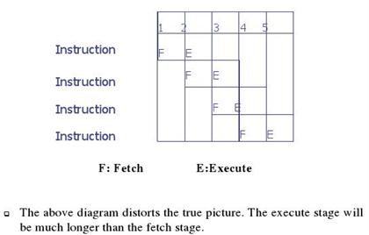

- Explain how the x86 instruction, ADD [SI], AX goes through different stages of execution. Write another instruction that would require the use of an indirect cycle. Use diagrams to supplement your answer.
Ans:
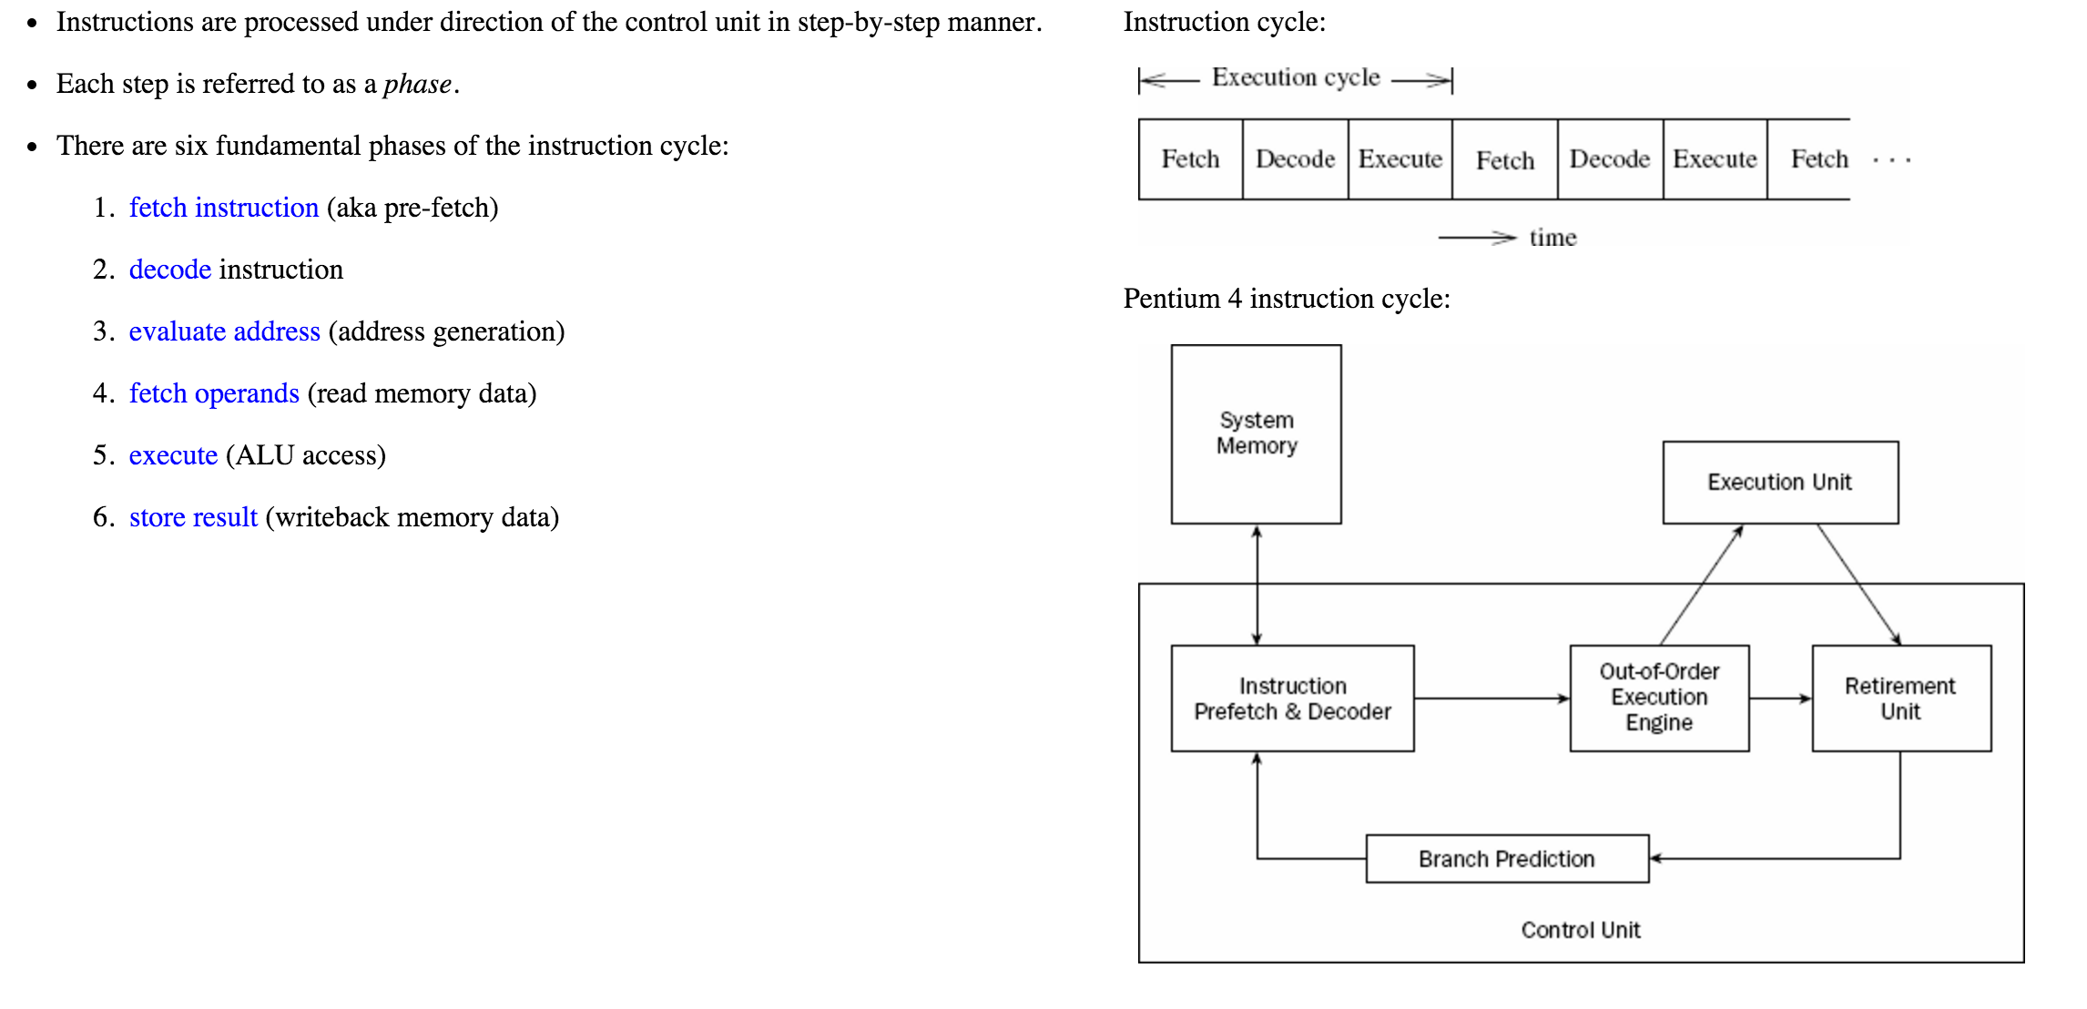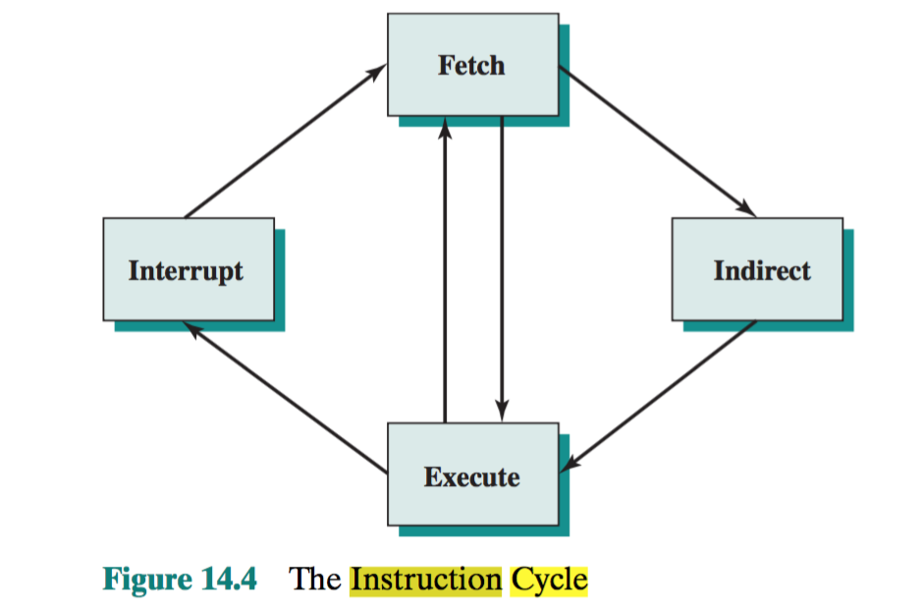

- Consider an instruction sequence of length n that is streaming through the instruction pipeline. Let p be the probability of encountering a conditional or unconditional branch instruction, and let q be the probability that execution of a branch instruction I causes a jump to a non-consecutive address. Assume that each jump requires the pipeline to be cleared, destroying all ongoing instruction processing, when I emerges from the last stage. Revise equations 14.1 and 14.2 to take these probabilities into account. Must show explanation to get any points.

Ans:
Let us count the first conditional branch as loop 1 as p is the probability of encountering a conditional or unconditional banch instruction and q as the probability of execution of a branch instruction.
As per the equations 14.1 and 14.2:
In the loop 11 when it is not taken as there is a stall after the load and the branches are assumed not to be taken.
In the loop 11 when it is taken as the branch is having single delay slot and the 1st load is having a single delay slot.

- One limitation of the multiple-stream approach to dealing with branches in a pipeline is that additional branches will be encountered before the first branch is resolved. Suggest two additional limitations or drawbacks.
Ans:
-The branch target cannot be fetched until the address is determined, which may require an address computation, depending on the addressing mode. This causes a delay in loading one of the streams. The delay may be increased if a component of the address calculation is a value that is not yet available, such as a displacement value in a register that has not yet been stored in the register. Other delays relate to contention for the register file and main memory
-The cost of replicating significant parts of the pipeline is substantial, making this mechanism of questionable cost effectiveness.
- Explain the impact of conditional branch on an instruction pipeline. List and explain the various ways in which an instruction pipeline can deal with conditional branch instructions. Why is a 2-stage instruction pipeline unlikely to cut instruction cycle time in half compared with the use of no pipeline?
Ans:
Multiple streams: A brute-force approach is to replicate the initial portions of the pipeline and allow the pipeline to fetch both instructions, making use of two streams. Pre-fetch branch target: When a conditional branch is recognized, the target of the branch is pre-fetched, in addition to the instruction following the branch. This target is then saved until the branch instruction is executed. If the branch is taken, the target has already been pre-fetched. Loop buffer: A loop buffer is a small, very-high-speed memory maintained by the instruction fetch stage of the pipeline and containing the n most recently fetched instructions, in sequence. If a branch is to be taken, the hardware first checks whether the branch target is within the buffer. If so, the next instruction is fetched from the buffer. Branch prediction: A prediction is made whether a conditional branch will be taken when executed, and subsequent instructions are fetched accordingly. Delayed branch: It is possible to improve pipeline performance by automatically rearranging instructions within a program, so that branch instructions occur later than actually desired.
- How history bits are used for branch prediction?
Ans: Dynamic branch strategies attempt to improve the accuracy of prediction by recording the history of conditional branch instructions in a program. For example, one or more bits can be associated with each conditional branch instruction that reflect the recent history of the instruction. These bits are referred to as a taken/ not taken switch that directs the processor to make a particular decision the next time the instruction is encountered. Typically, these history bits are not associated with the instruction in main memory. Rather, they are kept in temporary high- speed storage. One possibility is to associate these bits with any conditional branch instruction that is in a cache. When the instruction is replaced in the cache, its his- tory is lost. Another possibility is to maintain a small table for recently executed branch instructions with one or more history bits in each entry. The processor could access the table associatively, like a cache, or by using the low-order bits of the branch instruction’s address.
With a single bit, all that can be recorded is whether the last execution of this instruction resulted in a branch or not. A shortcoming of using a single bit appears in the case of a conditional branch instruction that is almost always taken, such as a loop instruction. With only one bit of history, an error in prediction will occur twice for each use of the loop: once on entering the loop, and once on exiting.
If two bits are used, they can be used to record the result of the last two instances of the execution of the associated instruction, or to record a state in some other fashion. Figure 14.18 shows a typical approach (see Problem 14.13 for other possibilities). Assume that the algorithm starts at the upper-left-hand corner of the flowchart. As long as each succeeding conditional branch instruction that is encountered is taken, the decision process predicts that the next branch will be taken. If a single prediction is wrong, the algorithm continues to predict that the next branch is taken. Only if two successive branches are not taken does the algo- rithm shift to the right-hand side of the flowchart. Subsequently, the algorithm will predict that branches are not taken until two branches in a row are taken. Thus, the algorithm requires two consecutive wrong predictions to change the pre- diction decision.
The decision process can be represented more compactly by a finite-state machine. The finite-state machine representation is commonly used in the literature.
The use of history bits, as just described, has one drawback: If the decision is made to take the branch, the target instruction cannot be fetched until the tar- get address, which is an operand in the conditional branch instruction, is decoded. Greater efficiency could be achieved if the instruction fetch could be initiated as soon as the branch decision is made. For this purpose, more information must be saved, in what is known as a branch target buffer, or a branch history table.

- What is a loop buffer? How is it useful? In which stage of the pipeline is it maintained?
Ans:
LOOP BUFFER: A loop buffer is a small, very-high-speed memory maintained by the instruction fetch stage of the pipeline and containing the n most recently fetched instructions, in sequence. If a branch is to be taken, the hardware first checks whether the branch target is within the buffer. If so, the next instruction is fetched from the buffer. The loop buffer has three benefits:
  - With the use of prefetching, the loop buffer will contain some instruction sequentially ahead of the current instruction fetch address. Thus, instructions fetched in sequence will be available without the usual memory access time.
  - If a branch occurs to a target just a few locations ahead of the address of the branch instruction, the target will already be in the buffer. This is use- ful for the rather common occurrence of IF–THEN and IF–THEN–ELSE sequences.
  - This strategy is particularly well suited to dealing with loops, or iterations; hence the name loop buffer. If the loop buffer is large enough to contain all the instructions in a loop, then those instructions need to be fetched from memory only once, for the first iteration. For subsequent iterations, all the needed instructions are already in the buffer.
- Derive an equation for speed-up when there are k stages and n instructions to be executed. What form does the equation take as n→∞?
Ans:
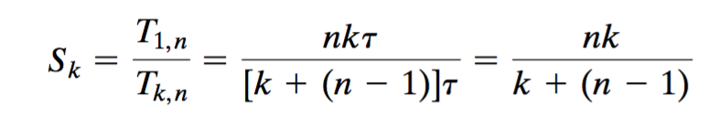

- What do you understand by data hazards?
Ans:
DATA HAZARDS: A data hazard occurs when there is a conflict in the access of an operand location. In general terms, we can state the hazard in this form: Two instructions in a program are to be executed in sequence and both access a particular memory or register operand. If the two instructions are executed in strict sequence, no problem occurs. However, if the instructions are executed in a pipeline, then it is possible for the operand value to be updated in such a way as to produce a different result than would occur with strict sequential execution. In other words, the program produces an incorrect result because of the use of pipelining.

